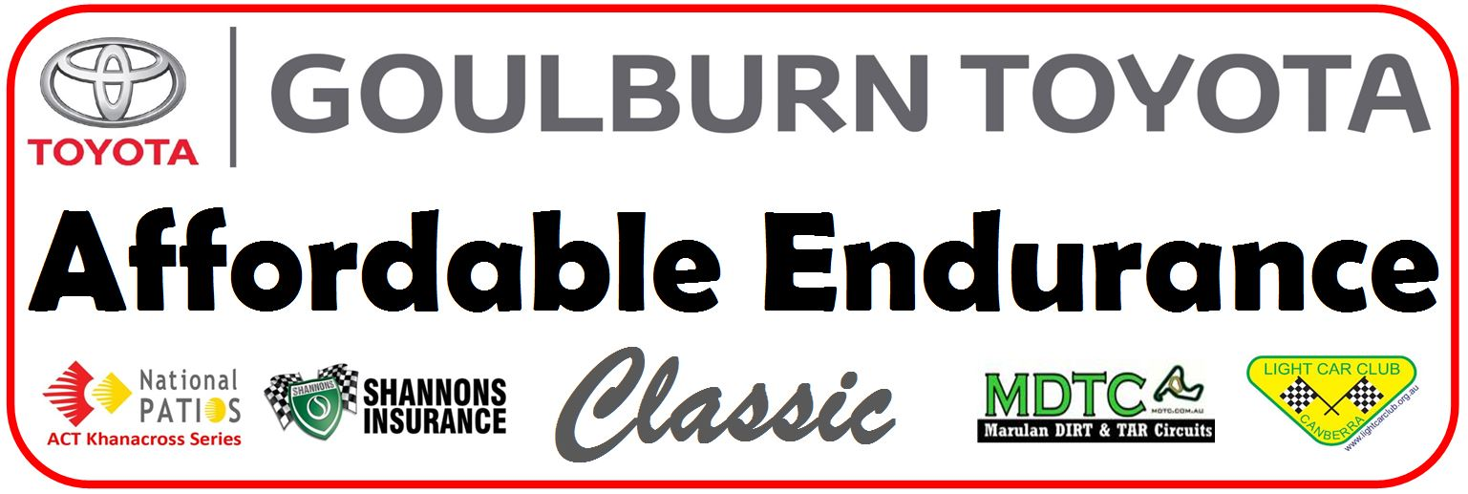
ENTRY FORM
Entrant Details (*Entrant may be one of the nominated drivers)
Name: __________________________________ DOB: ___/___/_____ Mobile Number: ___________________
Address: _________________________________________________________________________________
Suburb: ___________________________ State: ___________________ Postcode: ____________________
Driver Details (*each driver is required to complete a separate indemnity form prior to the event, and provide signed consent if under 18)
Driver 1 Name: _____________________________________________ Mobile Number: ___________________
Driver 2 Name: _____________________________________________ Mobile Number: ___________________
Driver 3 Name: _____________________________________________ Mobile Number: ___________________
Driver 4 Name: _____________________________________________ Mobile Number: ___________________
Team Manager Details (*Team Manager may cannot be a nominated driver for the event)
Name: _______________________________________________ Mobile Number: ____________________
Team Name (*this will be used for media and other promotional purposes – a team name may be disallowed if deemed to be inappropriate)
Our team name is: ___________________________________________________________________________
Vehicle Details
Make: _____________________ Model: ____________________ Year of Manufacture: ___________
Engine Capacity: ____________cc No. of Cylinders: ____________ FWD/RWD/4WD: ___________
Car Number Preference (*car number will be reserved once payment of the entry fee has been received by EFT)
First preference: ________ Second preference: ________ Third preference: ________
Entry Fee (*entry will be confirmed once payment of the entry fee has been received by EFT)
$650 per vehicle (three drivers) – payment is to be made by Electronic Funds Transfer prior to the event start
Details for EFT payment: BSB No: 032 778 Account No: 583450 Account Name: Light Car Club of Canberra Bank: Westpac Belconnen
(*use entrant or team name as the payment reference)

MDTC Facility Disclaimer
Motor vehicles and associated activities can be dangerous. I agree and acknowledge that as a condition of entry that Marulan Driver Training Centre Pty Ltd, land owners, management, employees, or agents shall not be under any liability for my death or injury, loss or damage to my property which may incur by me as a result of participating in or being present at this event except in regards to my rights under the trade practices act 1974. I acknowledge the Management have the right to decline or terminate my participation at any time for whatever reason. I have read the general terms and conditions provided by Marulan Driver Training Centre Pty Ltd and agree to adhere to the regulations and associated rules. I will thoroughly inspect the track and facilities and by using the track and facilities I acknowledge it to be in a safe condition for the activities I will undertake. If I observe changes to the track or facilities, I agree to notify management of the increased risk. By signing this facility disclaimer I agree and acknowledge that motor vehicles and associated activities can be dangerous and accidents can and do happen.

Declaration
I, __________________________________, being the entrant of the vehicle described in this entry application, declare that:
- the vehicle entered complies with all current rules and regulations as a permitted vehicle for the event;
- I agree that, should there be any eligibility issue found with the vehicle entered during scrutineering, during the event or after the event, that I accept and agree:
- to be disqualified from the event and be listed as a non-starter (DNS); and
- that the entry fee paid is forfeited and will not be refunded or transferred
- any driver who does not sign on prior to the driver’s briefing, does not attend the driver’s briefing or does not sign the driver’s briefing attendance form will be subject to a penalty at the discretion of the Promoter
- I agree that, at the discretion of the Promoter, randomly selected, or all vehicles, may be subject to post event checks for eligibility
- All drivers nominated on my entry will receive and review a copy of the current event regulations
- Any of the drivers in the event may be nominated for random drug and alcohol testing during the event

I agree, as an entrant in the Affordable Endurance Challenge held at the Marulan Dirt and Tarmac Circuits facility, that I understand the above and my vehicle and drivers will comply with the declaration and disclaimer above.
Signed: ________________________________ Date: _________________________________

Parent/Guardian Consent (*must be completed for competitors under 18 years of age)
I, _____________________________________________________________________________ (Name),
of _____________________________________________________________________________ (Address),
am the parent/guardian or ______________________________________ (please state) of the above-named
_____________________________________ (minor) who is under 18 years of age. I have read this document and understand its contents, including the exclusion of liability and assumption of risk and have explained the contents to the minor. I consent to the above-named minor participating in the event at his/her own risk.
Signed: ________________________________ Date: _________________________________

